* **(5 pts) - Paste your screen shots displaying all “required” messages (see sample above)**
* 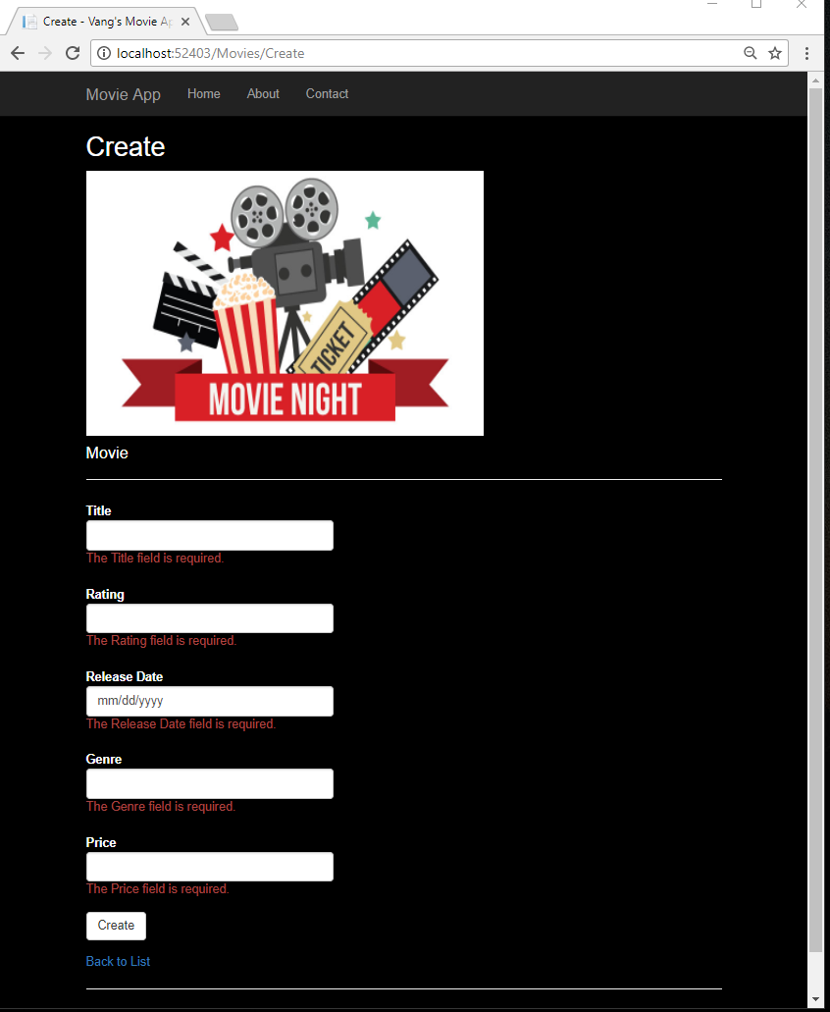**Note: The tutorial does not specify [Required] on all fields. Add [Required] to all model fields.**
* **(5 pts) - Paste your screen shot displaying all custom error messages (see sample above)**

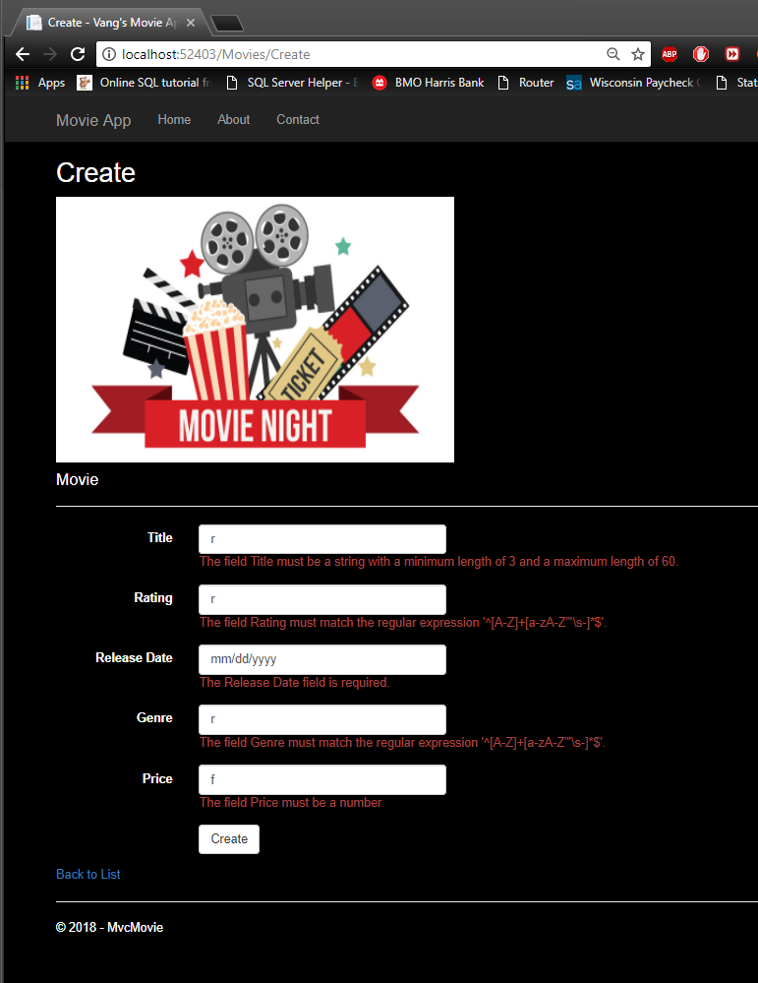

* 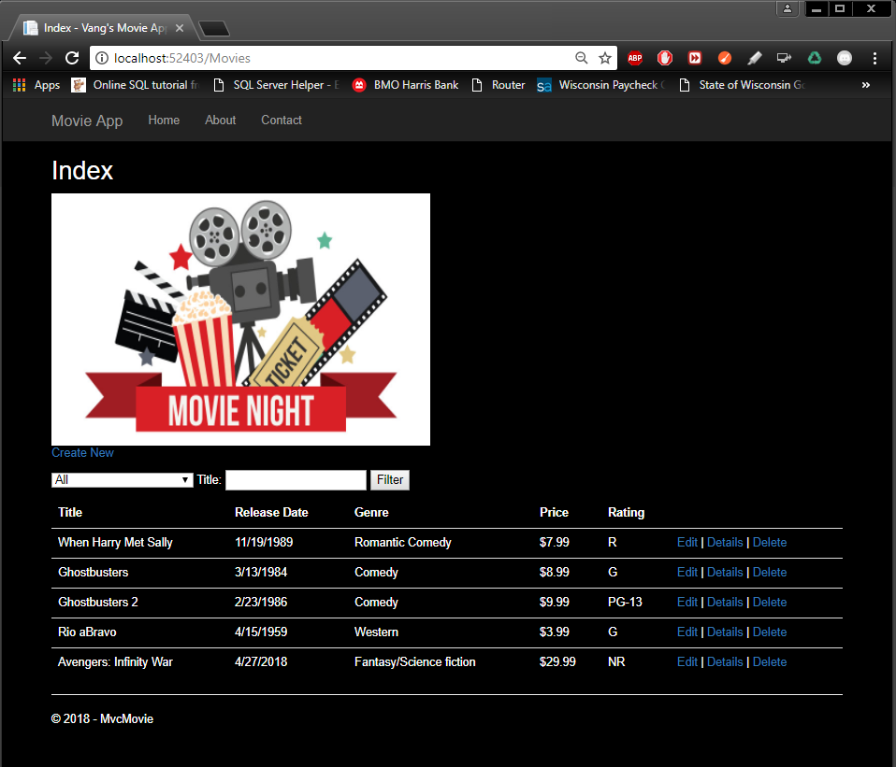**(5 pts) - Paste your screen shot displaying all your movies - BEFORE you delete one of your movies: FULL LIST BEFORE DELETE**
* 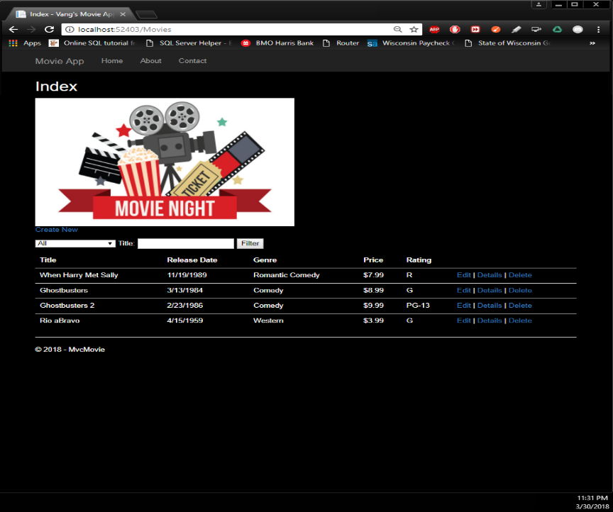**(5 pts) - Paste your screen shot displaying all remaining movies - AFTER you deleted one of your movies: DELETED AVENGERS**